RANK | ILLUSTRATED
- Taylor Swift: A Little Golden Book Biography
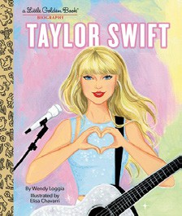



Wendy Loggia, Elisa Chavarri (Illus.), Golden Books,
$5.99
- Bluey: Hooray, It’s Easter!
Penguin Young Readers, $9.99
- Goodnight Moon
Margaret Wise Brown, Clement Hurd (Illus.), Harper, $10.99
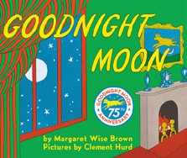

- The Very Hungry Caterpillar
Eric Carle, World of Eric Carle, $10.99
- Buffalo Fluffalo
Bess Kalb, Erin Kraan (Illus.), Random House Studio, $18.99
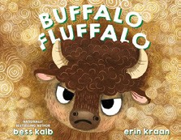

- Grumpy Monkey Spring Fever
Suzanne Lang, Max Lang (Illus.), Random House Studio, $11.99
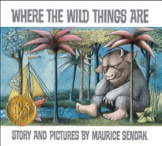
- Bluey: Easter
Penguin Young Readers, $5.99
- Pat the Bunny
Dorothy Kunhardt, Golden Books, $9.99
- Where the Wild Things Are
Maurice Sendak, Harper, $21.99
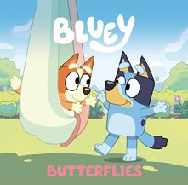
- Bluey: Butterflies
Penguin Young Readers, $5.99
- Bear Finds Eggs
Karma Wilson, Jane Chapman (Illus.), Margaret K. McElderry Books, $18.99
- Luigi, the Spider Who Wanted to Be a Kitten
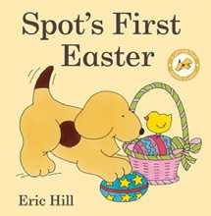

Michelle Knudsen, Kevin Hawkes (Illus.), Candlewick,
$18.99
- Little Blue Truck’s Springtime: An Easter And Springtime Book For Kids
Alice Schertle, Jill McElmurry (Illus.), HMH Books for Young Readers, $13.99
- Dragon’s First Taco
Adam Rubin, Daniel Salmieri (Illus.), Dial Books, $8.99
- Spot’s First Easter

Eric Hill, Warne, $8.99
March 27, 2024
For the week ending March 24, 2024 based on sales in hundreds of independent bookstores nationwide.
CHILDREN’S

RANK | SERIES
- Dog Man (hardcover)
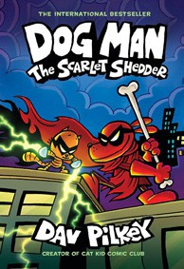

Dav Pilkey, Graphix
New in Series: The Scarlet Shedder
- Percy Jackson and the Olympians
Rick Riordan, Hyperion
- Diary of a Wimpy Kid (hardcover)
Jeff Kinney, Amulet
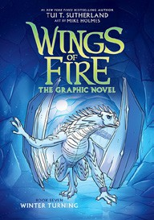

- Elephant & Piggie (hardcover)
Mo Willems, Hyperion
- Wings of Fire
Tui T. Sutherland, Scholastic
- InvestiGators (hardcover)
John Patrick Green, Christopher Hastings, Pat Lewis (Illus.), First Second
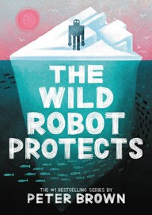

- Spy School
Stuart Gibbs, Simon & Schuster Books for Young Readers
- Wild Robot
Peter Brown, Little, Brown Books for Young Readers
- I Survived
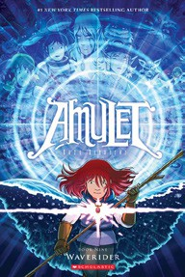

Lauren Tarshis, Álvaro Sarraseca (Illus.), Scholastic
- Amulet
Kazu Kibuishi, Graphix

All Fiction Series titles are hardcover and paperback unless noted.
Debut


Indies Introduce

OTHER CHILDREN’S INDIE FAVORITES
AGES 4 TO 8
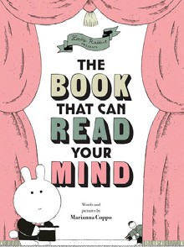

The Book That Can Read Your Mind
Marianna Coppo, Chronicle Books, $17.99 “Abracadabra! This interactive story is filled with adorable
illustrations, and the undeniably fun choose-your-own-adventure style makes for a new read every time. Perfect for parents who can’t bear to read the same book over and over.”
—Mary Wahlmeier Bracciano, Raven Book Store, Lawrence, KS

Based on reporting from hundreds of independent bookstores across the United States. Copyright 2024 American Booksellers Association. All rights reserved.

