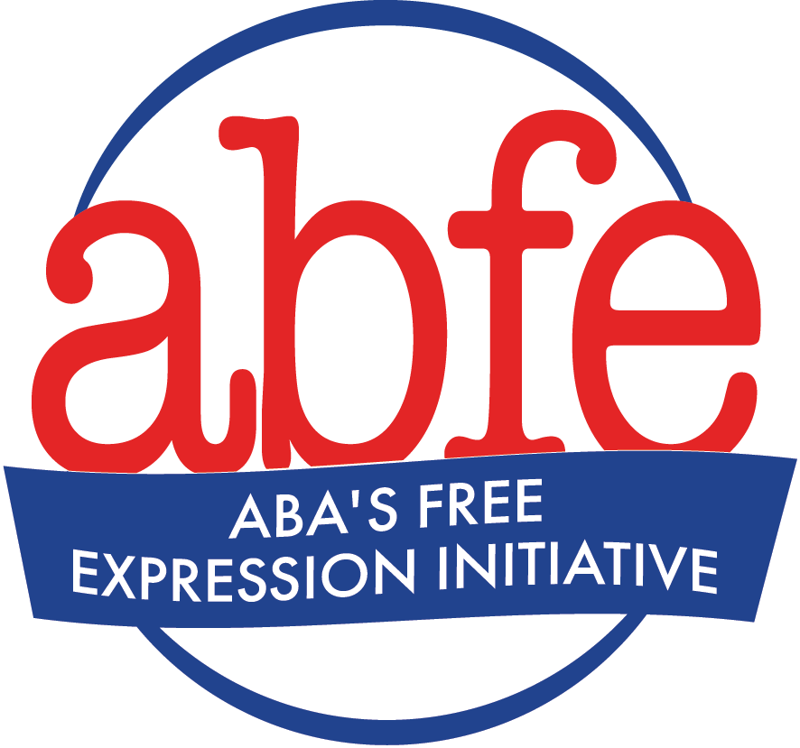

Freedom of Expression, Equity, Access, and Representation, & Customer Privacy Template Statements

Freedom of Expression Statement
The shelves of our bookstore hold a wide array of titles containing ideas as diverse as the world in which we live. We believe a diverse selection of books is crucial to a bookstore’s role of sharing ideas to bring people together, helping individuals see themselves in the stories of others, enhancing empathy and understanding of differences, and providing diverse viewpoints to broaden perspectives. We hope we have provided a broad selection of books that make that possible for you, and we hope you support our efforts to make that possible for everyone. We trust that you will make your own decisions about which of these books you choose to read or not to read.

Equity, Access, and Representation/Freedom of Expression Statement
Our store has a strong commitment to diversity, equity, and inclusion that we demonstrate in a variety of ways, including ensuring representation in our inventory and equity in our business practices. At the same time, we may carry some titles that offend some people or that may seem to some people to be counter to that commitment. We believe a diverse selection of books is crucial to a bookstore’s role of sharing ideas to bring people together, helping individuals see themselves in the stories of others, enhancing empathy and understanding of differences, and providing diverse viewpoints to broaden our perspectives. We believe our role is to make books available and we trust that you will make your own decisions about which of these books you choose to read or not to read.

Customer Privacy Statement
We believe that it is our responsibility to respect the privacy of your choice of books, magazines, and other material. We will not sell information identifying your purchases to a third party without your permission or otherwise disclose it to anyone, including the government, on our own initiative.

