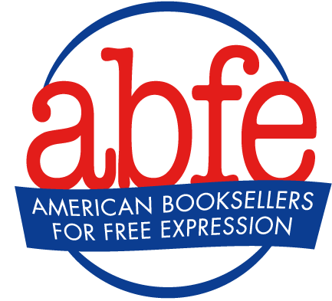
Handling a Records Request About School District Orders

With the growing partisan attacks on books in schools across the country, independent bookstores that supply school districts with books may receive records requests from individuals or groups seeking to know which book titles schools have purchased. It is important that bookstores know their rights and are prepared for how to best respond to such requests.

Only persons acting pursuant to a court order can force you to turn over personal information about your customers, including school districts. You are not required to hand over records just because someone asks you to. (For information on what a court order, search warrant, or subpoena is and how to handle them, please see ABFE’s Q&A Protecting Consumer Privacy in Bookstores).

In response to a records request about books your store has sold to a school district, try using language like:

We believe that it is our responsibility to respect the privacy of our customers’ choice of books, magazines, and other material. We treat school districts no different than individual customers and do not provide information identifying their purchases without their permission or otherwise disclose that information to anyone on our own initiative. The U.S. Supreme Court has ruled that privacy and anonymity is a cornerstone of free speech. In accordance with the First and Fourteenth amendments, school districts should be free to decide which books to purchase to best serve their students.

As an independent bookstore in the community, it is our role to facilitate the sharing of ideas. We hope to help individuals see themselves in the stories of others, enhance empathy and understanding of differences, and provide diverse viewpoints to broaden perspectives. We believe in protecting the rights of readers and the importance of representation in books. For some students, school libraries may be the only place to access reading materials. Therefore, it is crucial that school libraries carry books that reflect and affirm the experiences and identities of all young people. It is equally important that young people also see experiences and identities different from their own. We are proud to help provide schools with the resources to do this. We trust that students and their families will make their own decisions about which books they choose to read or not to read without preventing others from doing the same.

