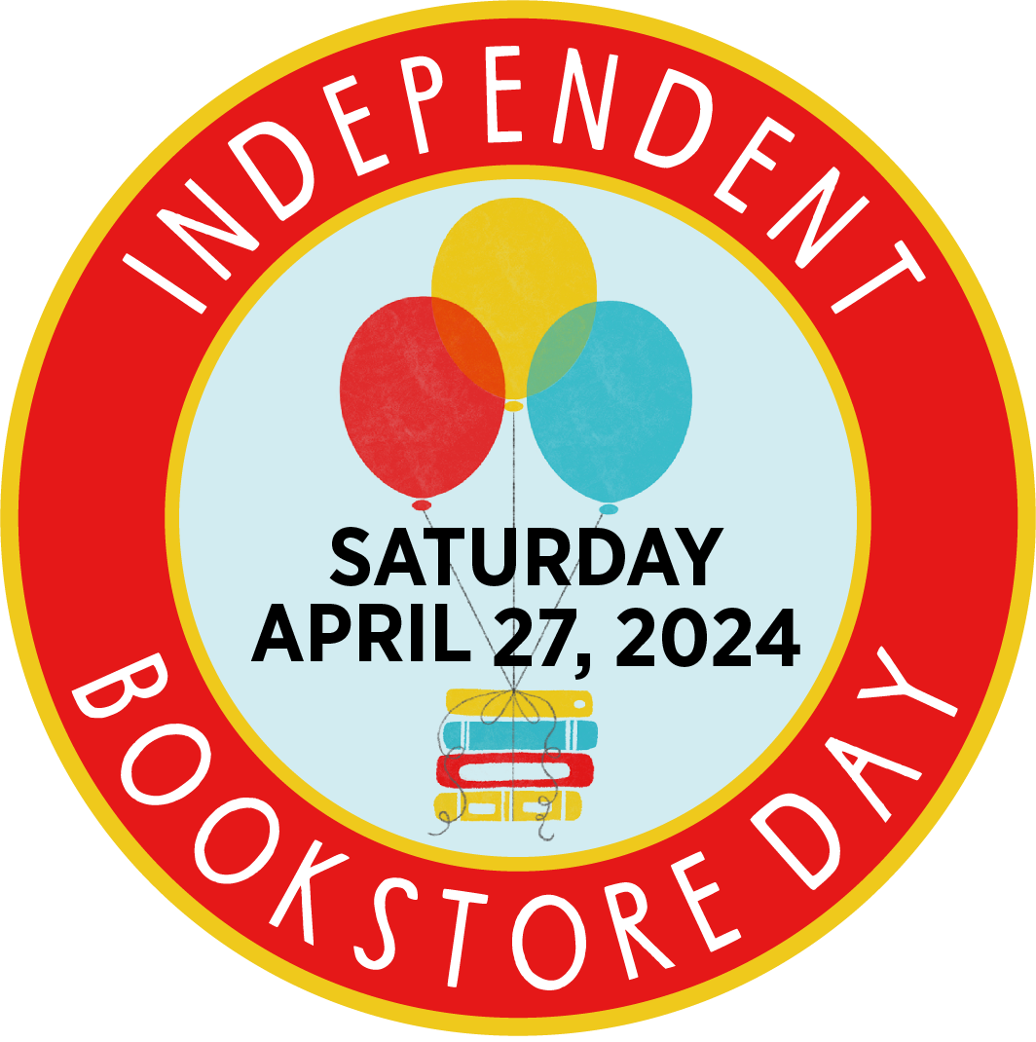

[Insert Your Name]
[Insert Bookstore Name]
[Insert email address/contact information]

Independent Bookstores Day Celebrates its 11th Anniversary

Annual Day Celebrated on April 27, 2024

[INSERT YOUR CITY, STATE] — [Insert store name] is happy to announce our participation in the 11th Anniversary of Independent Bookstore Day!

[Insert your bookstore information/events here: see examples on next page]

[Insert bookseller/bookstore owner quote: see examples on next page]

Independent Bookstore Day (Indie Bookstore Day) was established in 2013 to promote, celebrate, and highlight the value of the Independent bookstore community. The day has been observed on the last Saturday of April every year since 2013. This year there are over 900 stores participating across the country.

Independent Bookstore Day is organized by the American Booksellers Association, a national not-for-profit trade organization, that works with booksellers and industry partners to ensure the success and profitability of independently owned book retailers, and to assist in expanding the community of the book.

ABOUT [INSERT STORE NAME]

[Insert store “About” information, such as opening date, bookstore focus, and mission]

# # #

Examples of Quotes for Indie Bookstore Day Press Release:

Bookstore information/events
Corner Store Books will have over 30 exclusive items for sale and as giveaways, from specialized tote bags, to banned books puzzles and water bottles. There will be food and raffle prizes from local vendors and games and activities for children such as bookstore bingo.

This year, Corner Store Books will celebrate Independent Bookstore Day with a sidewalk sale and have at least a dozen authors on hand to sign their books, including [Author 1], [Author 2], and [Author 3]. There is also a chance to win an Indie Bookstore Day tote bag filled with Independent Bookstore Day exclusives and store merchandise.

Bookseller/bookstore owner quote
“Independent Bookstore Day is one of our favorite days. It both celebrates the bookseller and the book buyer. We are so excited to have participated for the last five years and look forward to many more.” —John Doe, Owner, Corner Store Books.

“Corner Store Books participates in Indie Bookstore Day because we always have a really fun, lively lineup of visitors and guests and things to do, and we’re looking forward to celebrating again.” —John Doe, Owner, Corner Store Books.

“It’s really a time to put indie bookstores back in the center of the story. Indie Bookstore Day is a way to say thank you to our loyal and supportive customers.” —John Doe, Owner, Corner Store Books.

