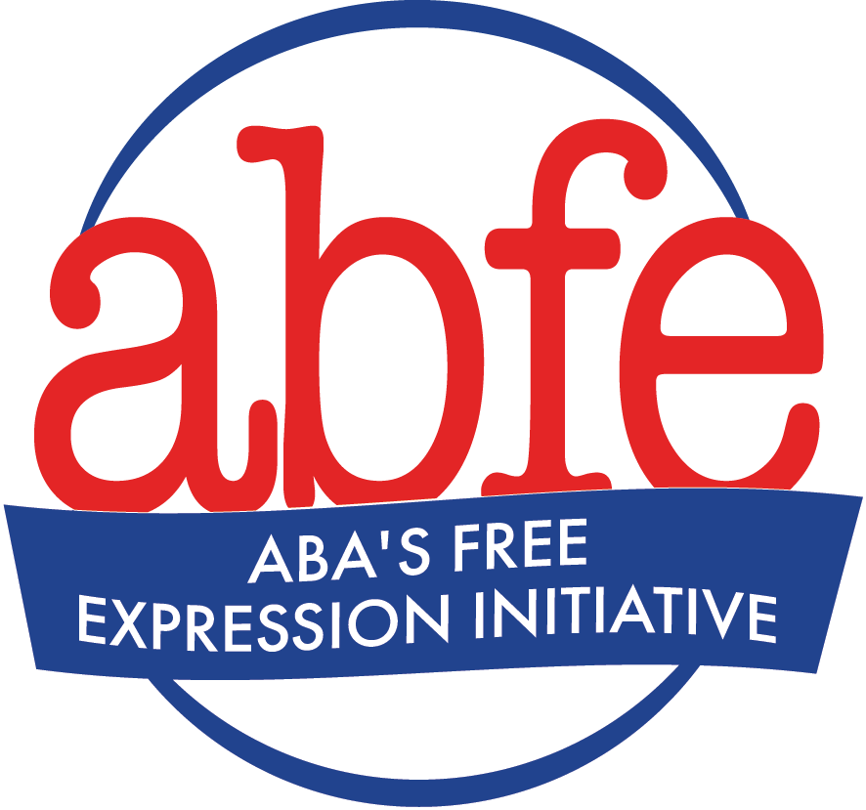

Preparing for Controversial Author Events

- Invest some time in considering your reasons for hosting the event. Being clear with your intention will help you be clear in your messaging, communications, and, if necessary, defense. Refer to ABFE’s Freedom of Expression, Equity, Access, and Representation, & Customer Privacy Template Statements for example position statements.
- Before booking an author event, have a transparent conversation with your staff. Listen carefully to what your staff has to say and take their concerns seriously. Your employees’ mental and physical safety is paramount. If you decide to book the author event following the conversation with your staff, let them know your decision and what informed it. Also let them know that they can be assigned a different shift if they wish to not be present for the author event.
- Remember, protesters are exercising their free speech rights, too. Treat them with respect. Help your staff prepare for how to handle protesters so that they feel prepared and supported.
- Prepare a short statement from the store on why the event is being held, why you believe it’s important to have this discussion in your community, and whatever else you believe needs to be addressed. Keep the statement short and to the point. Share it with staff and keep it handy to respond to the press, customers, or social media.
- Inform neighboring stores about what’s going on. Share your statement with them and make sure they know you are trying to minimize the impact on their businesses.
- It is within your First Amendment rights to curate comments on your store’s social media. Depending on the event, it may make sense to close or closely monitor your social media accounts to block or remove offensive or inappropriate comments. Periodically check in with staff members monitoring social media for inappropriate comments. Offer them the support they need to minimize the impact on their mental health.
- If picketing is threatened, know your property boundaries so you can point out to protesters where your private property starts and their right to picket ends. Make sure your staff is informed as well, both about the boundaries and how to have those conversations with picketers safely.
- If the situation with protesters is escalating, try using a variety of de-escalation techniques. See this de-escalation workshop recap and these top 10 things to know about non-violent communication & de-escalation. Train your staff on de-escalation, safety, and protestors’ rights.
- Whenever possible, use de-escalation techniques to diffuse tense situations. The decision to involve police must be very carefully considered and should be based on your and your staff’s trust in, and/or relationship with, local police -- a good discussion to have in general with your staff. Before making the decision to involve the police, consider whether their involvement will escalate or de-escalate the situation, support staff’s safety, or put staff’s safety at risk. If calling the police does not seem to be an option, discuss alternatives ahead of time so that safety is still paramount.
- Potentially contentious discussions or talks may benefit from having a moderator. Consider a skilled facilitator and store supporter -- an author, professor, activist, social worker, businessperson -- who could offer unbiased facilitation to ensure that everyone is heard.
- If you are unsure how to handle concerns regarding an author event, want to discuss your plans, or ask questions about best practices, please contact ABFE Director Dave Grogan at (914) 406-7562 or abfe@bookweb.org.

