For Immediate Release: [[DATE]]

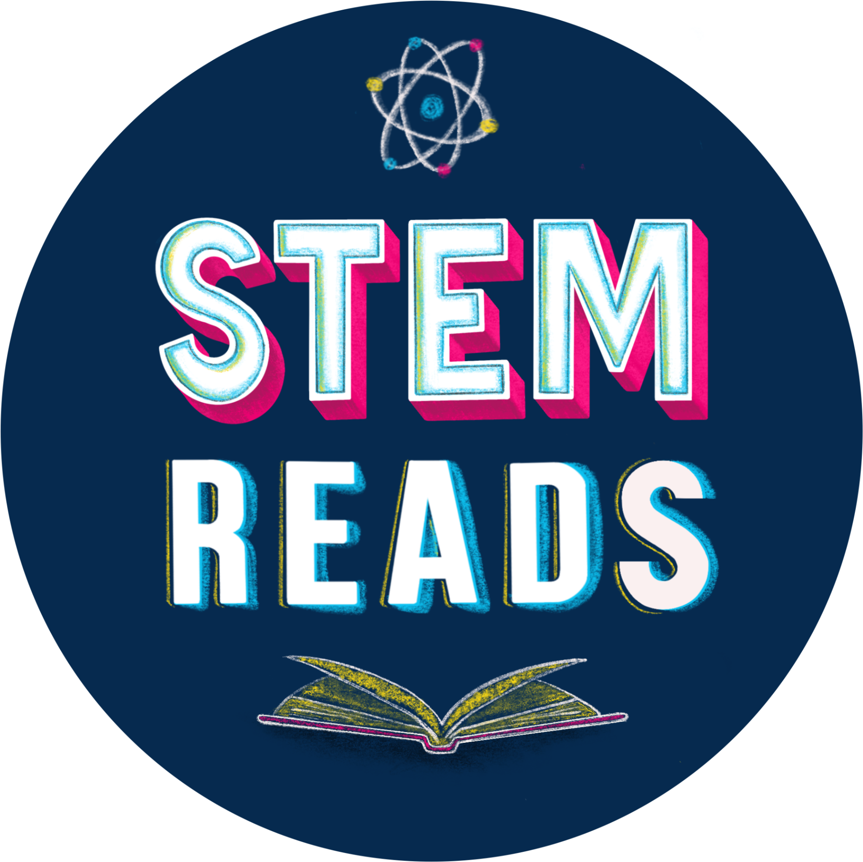

[[Bookstore contact name]]
[[Bookstore contact title]]
[[Bookstore name]]
[[Bookstore location]]
[[Bookstore contact email address]]

[[BOOKSTORE NAME]], TO GIVE AWAY CHRISTINA SOONTORNVAT’S THE LAST MAPMAKER TO KIDS IN UNDERSERVED COMMUNITIES

General Motors, Candlewick Press, and the American Booksellers Association are partnering with indie bookstores across the country for the “STEM Reads” Book Giveaway

City, State: This [[season]], [[indie bookstore name]] is distributing [[x number]] of special-edition copies of bestselling author Christina Soontornvat’s latest book, The Last Mapmaker, to underserved young readers throughout the community.

The American Booksellers Association (ABA), Candlewick Press, and General Motors are working together with indie bookstores to distribute 20,000 copies of The Last Mapmaker as part of the “STEM Reads” (#STEMReads) book giveaway. The program, funded by General Motors, aims to encourage young readers to explore their interests in science, technology, engineering, and mathematics (STEM) through consuming science fiction and fantasy writings.

The Last Mapmaker is a resolute, high-seas middle-grade adventure set in a Thai-inspired fantasy world.

[Local indie bookstore, located at x address, is giving away x number of books to kids at x events. Use bullets to illustrate plans.]

Soontornvat is the award-winning author of more than a dozen books for children of all ages, including Newbery Honor books A Wish in the Dark and All Thirteen: The Incredible Cave Rescue of the Thai Boys’ Soccer Team. In addition to being an author, she is passionate about STEM and STEAM and holds a bachelor’s degree in mechanical engineering and a master’s degree in science education.

ABOUT

[Bookstore Name] [Insert boilerplate of 3-4 sentences plus web address]

###

