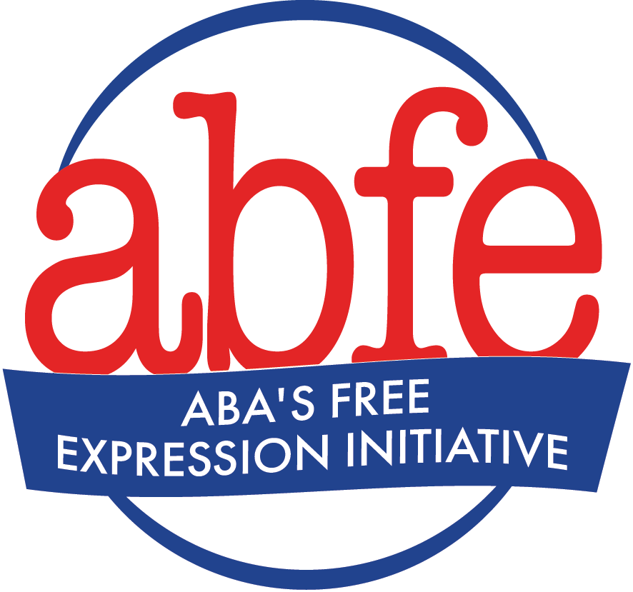

Talking Points for School and Library Book Bans

Freedom of Expression Focus

Our bookstore holds a wide array of titles containing ideas as diverse as the world in which we live. We believe a diverse selection of books is crucial to our role in sharing ideas. The same is true for schools and libraries. Not every book is for every child, but every child should have access to books that speak to their interests and experiences. Books are crucial to children’s development, helping children to see themselves in the stories of others, enhancing empathy and understanding of differences, and providing diverse viewpoints to broaden perspectives. We implore that you make this possible for all children and trust children and parents to decide which books to read or not to read.

Procedural Violations Focus

As a bookstore that believes a diverse selection of books is crucial in sharing ideas, we are concerned to learn that books have been removed from the shelves pending the outcome of the challenges against them, in contrast to stated policy. We ask that you return the books until the challenges have been resolved and instruct personnel to comply with the adopted policy in the future.

Equity, Access, and Representation -- Anti-Racism Focus

Our store has a strong commitment to diversity, equity, and inclusion that we demonstrate in a variety of ways, including ensuring representation in our inventory and equity in our business practices. We believe that schools and libraries should also reflect these ideals. The freedom to read stories and learn about people from diverse backgrounds is key in raising an informed next generation. In order to understand people’s lived experiences today and shape a better tomorrow, we must acknowledge how these experiences are influenced by institutionalized policies that marginalize certain racial groups. Censoring narratives of historically marginalized groups leaves ignorance and prejudice unchallenged and can reinforce feelings of isolation, marginalization, and shame among children who identify as part of an underrepresented group. Additionally, censoring these narratives denies other children the opportunity to learn about other people’s experiences. We encourage you to protect books about people from all backgrounds to help children enhance their empathy, broaden their perspectives, and see themselves in the stories of others.

Equity, Access, and Representation -- LGBTQIA2S+ Focus

Our store has a strong commitment to diversity, equity, and inclusion that we demonstrate in a variety of ways, including ensuring representation in our inventory and equity in our business practices. We believe that schools and libraries should also reflect these ideals. The freedom to read stories about people of diverse sexual and gender identities validates and empowers all youth, especially those who identify as LGBTQIA2S+. When children see gender expression journeys in literature, this allows them to fully realize their own personal journeys. In contrast, when LGBTQIA2S+ children do not see themselves represented in the stories around them, they can internalize negative messages about the value of their own personal stories. LGBTQIA2S+ students are 140 times more likely than non-LGBTQIA2S+ students to miss school due to safety concerns, and 1 out of 3 LGBTQIA2S+ youth attempt suicide or have suicidal thoughts. However, youth in schools with pro-LGBTQIA2S+ policies report fewer thoughts of suicide. Additionally, LGBTQIA2S+ representation in books promotes value and acceptance of all human differences. We encourage you to protect LGBTQIA2S+ books to help all children enhance their empathy, broaden their perspectives, and see themselves in the stories of others.

